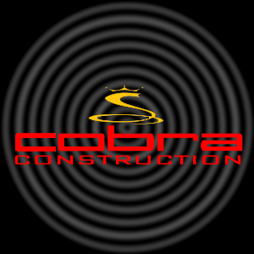

COBRA CONSTRUCTION

Creations for the future

15997 Woodbine Circle Vernon Hills, IL, 60061